Software Requirement Specifications
E-COMMERCE WEBSITE



Submitted by
Qudsia Amber S23BINFT1M01074
Submitted to
Mam Sara Fareed

Department of Information Technology
Faculty of Computing
The Islamia University of Bahawalpur

Meeting Details
Sr. No | Details | Date | Supervisor Signature

Summary
This Software Requirements Specification (SRS) describes the development of an E-Commerce website that provides a seamless and efficient online shopping experience. The system aims to overcome the limitations of traditional retail, such as geographical constraints, time restrictions, and manual operations, by offering a platform accessible anytime and from anywhere.
The system supports both customers and administrators. Customers can register, browse products by category, add items to a shopping cart, place orders, track deliveries, and leave reviews. Administrators can manage product listings, orders, user accounts, inventory, and customer feedback through a centralized dashboard.
Core features include user authentication, payment integration, shipment tracking, real-time order updates, and notification systems. The platform is developed using HTML, CSS, and JavaScript for the front-end, with Node.js as the back-end, and MySQL or PostgreSQL for data management.
The system focuses on performance, scalability, security, and user-friendliness. Security measures such as SSL/TLS encryption and regular backups ensure data protection. This SRS defines both functional and non-functional requirements and provides a foundation for system design, development, and testing.

Table of Contents
1. Introduction 4
1.1. Purpose 4
1.2. Scope 4
1.3. Product Perspective 4
1.4. User Characteristics 4
1.5. Similar apps and systems/Literature Review 4
1.6. Proposed Technologies 4
2. Requirements 5
2.1. Function Requirements 5
2.1.1. Sign Up 5
2.2. Non-Functional Requirements 5
3. Use Cases and Flow of Processes 6
3.1. Use Case 1 7
4. References 8

- Introduction
This Software Requirements Specification (SRS) document outlines the design and development of an E-Commerce Website aimed at providing a seamless and efficient online shopping experience. The goal is to overcome the limitations of traditional retail methods—such as geographical constraints, time restrictions, and manual operations—by offering a digital platform accessible from anywhere at any time.
The system is designed to support both customers and administrators. Customers will be able to register, browse products by category, add items to a shopping cart, place secure orders, track deliveries, and leave reviews. Administrators will have access to tools for managing product listings, orders, user accounts, inventory, and customer feedback through a centralized dashboard.
Core features include secure user authentication via email, mobile, or social media, integration of a payment gateway, shipment tracking, real-time order updates, and notification systems. The platform will be developed using HTML, CSS, and JavaScript for the front-end, with Node.js serving as the back-end technology. Data management will be handled using a robust database system such as MySQL or PostgreSQL.
Emphasis is placed on performance, scalability, security, and user-friendliness. Security measures like SSL/TLS encryption and regular backups will ensure data integrity and transaction safety. This SRS defines both the functional and non-functional requirements of the system and provides a comprehensive foundation for the project's design, development, and testing phases.

  - Purpose

The purpose of this e-commerce website is to provide a modern, user-friendly digital platform that enables seamless online shopping and selling. It aims to transform the traditional shopping experience by offering convenience, accessibility, and efficiency to users. Through this system, customers can browse a wide range of products, compare prices, read reviews, and make secure purchases from the comfort of their homes. For sellers, the website simplifies product management, order tracking, and customer interactions through a well-organized admin panel. By reducing the dependency on physical stores and minimizing operational costs, the platform supports the growing trend of digital commerce and enhances business reach. Overall, the project seeks to deliver a responsive, secure, and scalable solution that meets the evolving needs of both buyers and sellers in the online marketplace
  - Scope
- Provide a user-friendly platform for online product browsing and purchasing.
- Enable secure customer registration and login.
- Allow product categorization and detailed product listings.
- Support shopping cart functionality and order placement.
- Integrate a secure payment gateway for online transactions.
- Offer order tracking and shipment status updates.
- Enable users to post reviews and rate products.
- Provide an admin dashboard for managing.
- Product inventory
- User accounts
- Orders and shipments
  - Product Perspective
This website is entirely new product designed to server as an independent
online marketplace for selling fashion, cosmetics, and electronics items. It is designed to make online shopping easy for customers, letting them to browse product, buy items, pay for them and track their orders, all in one place.
The system will integrate with external services such as:
- Payment Gateways (e.g. stripe) for secure transaction.
- Shipping and Courier APIs for real time order tracking.
- E-Mail notification services to upgrades customer about order confirmation.
  - User Characteristics
The system is designed for two main types of users: customers and administrators, each with different roles and skill levels.
Customers are general users who visit the website to browse and purchase products. They are expected to have basic knowledge of using web browsers and navigating websites. Customers may vary in age, background, and technical experience, so the system should be simple, intuitive, and easy to use. They interact with features such as registration, product browsing, cart management, order placement, tracking, and reviews.
Administrators are responsible for managing the overall system. They are expected to have moderate technical knowledge and familiarity with web-based systems. Administrators use the dashboard to manage products, inventory, orders, user accounts, and customer feedback. They require a more structured and efficient interface to handle system operations effectively.
Overall, the system is designed to be user-friendly for beginners while also providing sufficient functionality and control for administrators.
  - Similar apps and systems/Literature Review
Several existing e-commerce platforms and studies provide a foundation for the development of this system.
Popular platforms such as Amazon and Shopify are widely used in the e-commerce industry. Amazon operates as a large online marketplace where multiple sellers can list products, manage orders, and reach a wide customer base. It provides structured product listings, customer reviews, and reliable order tracking. On the other hand, Shopify allows businesses to create their own customized online stores with full control over design, branding, and product management. It offers tools for inventory management, order processing, and customer interaction.
Research studies highlight that e-commerce systems play a major role in modern business by enabling online buying and selling through internet-based platforms. These systems improve accessibility, reduce operational limitations, and support business growth.
A systematic literature review on e-commerce websites emphasizes that website design, usability, and simplicity are key factors influencing customer trust and user experience. A well-designed interface with easy navigation and accurate information increases user satisfaction and engagement.
Additionally, studies on e-commerce supply chain management show that efficient order processing, logistics integration, and real-time tracking are essential for achieving competitive advantage and improving overall system performance.
Overall, these existing systems and research works highlight the importance of user-friendly design, efficient management features, and reliable order handling, which are incorporated into the proposed e-commerce system.
  - Proposed Technologies
Python, Django, SQLite, Bootstrap 4, HTML/CSS, Django ORM, SMTP (Email Service), WSGI, The Back-end must be developed using PHP (Laravel framework preferred) or Node.js

- Requirements
  - The proposed e-commerce system is designed to provide a complete online shopping solution for customers and administrators. It allows customers to register an account, log in securely, browse products by category, search for specific items, and view detailed product information. Customers can add products to a shopping cart, manage selected items, place orders using Cash on Delivery, track order status, and submit product reviews and ratings. On the other hand, administrators can manage the overall system by adding, updating, and deleting product listings, managing inventory and stock levels, handling customer accounts, and monitoring orders and their delivery status. The system also supports managing customer feedback to improve service quality. Additionally, it includes secure user authentication to ensure only authorized users can access their accounts and admin features. The system ensures smooth operation of core functions such as product management, order processing, and user interaction, providing an efficient and user-friendly online shopping experience.
  - Function Requirements
This section describes the functional requirements of this web-based system in natural language. The requirements are organized by system feature using the functional requirements template given below:
FR-1: Registration
Identifier | FR-1
Title | Registration
Requirement | The customer shall be able to register an account using username and password
Source | Stakeholder
Rationale | To enable personalized shopping
Business rule | Username must be unique
Dependencies | None
Priority | high

FR-2:login
Identifier | FR-2
Title | Login
Requirement | The system will authenticate user based on registered username and password
Source | Stakeholder
Rationale | To allow source access to user accounts
Business rule | FR-1: maximum 3 login attempts allowed
Dependencies | Depend on FR-1
Priority | High

FR-3: Search Product
Identifier | FR-3
Title | Search product
Requirement | The customer will be able to view product by category and search keywords
Source | Stakeholder
Rationale | To allow easy discovery of products
Business rule | None
Dependencies | None
Priority | High

FR-4: Add to Cart
Identifier | FR-4
Title | Add to Cart
Requirement | The user will be able to add selected product to the shipping cart
Source | Stakeholder
Rationale | To enable product collection before purchasing
Business rule | Product must be in stock
Dependencies | FE-2 and FR-3(login and browsing)
Priority | High

FR-5: Remove From Cart
Identifier | FR-5
Title | Remove from cart
Requirement | Users will be able to remove product from their cart
Source | Stakeholder
Rationale | Allow users to modify their selections before purchase
Business rule | None
Dependencies | FR-4(add to cart)
Priority | Medium

FR-6: Place Order
Identifier | FR-6
Title | Place order
Requirement | Allow users to place order for available product
Source | Stakeholder
Rationale | Allow user to purchase selected product
Business rule | FR-1 and FR-2(registration and logged in)
Dependencies | Availability of selected product
Priority | High

FR-7: Make payment
Identifier | FR-7
Title | Make payment
Requirement | System shall process payment online using third party payment gateway
Source | Stakeholder (user)
Rationale | To enable source and real time payment recessing and to confirm order
Business rule | Only valid order
Dependencies | FR-2(login)
Priority | High

FR-8: Admin login
Identifier | FR-8
Title | Admin login
Requirement | Admin will be able to log into the admin dashboard securely
Source | Admin
Rationale | To access system management features
Business rule | Admin credentials must be verified
Dependencies | Registration as admin
Priority | high

FR-9: Manage product
Identifier | FR-9
Title | Manage product
Requirement | Admin will able to add edit and remove product information
Source | Admin
Rationale | To keep the product catalog up to date
Business rule | Deleted product will not affect existing order
Dependencies | Depends on admin login
Priority | High

  - Non-Functional Requirements
Following are the non-functional requirements.
- Performance
Requirements about speed, response time, resource usage and capacity.
- Security
Ensure secure authentication and data storage using SLL / TLS encryption.
- Scalability
The system should be flexible for the future enhancements
- Availability
Requirements about system uptime and maintenance.
Usability
USE-1: The system will allow a new user to register and place order without training
USE-2: The system will allow user to navigate from home page to product page.
USE-3: The system will display error message when user enter invalid data
USE-4: The website will design with simple navigation and user-friendly layout
USE-5: The system provides help icons for all major actions like “login”, “Add to Cart”, “Place Order” etc.
Performance
PER-1: 95% of all product and category pages shall load completely within
3 second over a 10 Mbps or faster internet connection
PER-2: The system should at least 1000 current users performing browsing, ordering and payment actions without performance degradation
PER-3: The system will process a payment and return confirmation within 5 second after the user submit payment details
PER-4: Search queries shall return result within 2 second for 95% of cases

- Use Cases and Flow of Processes
Use Case Diagram
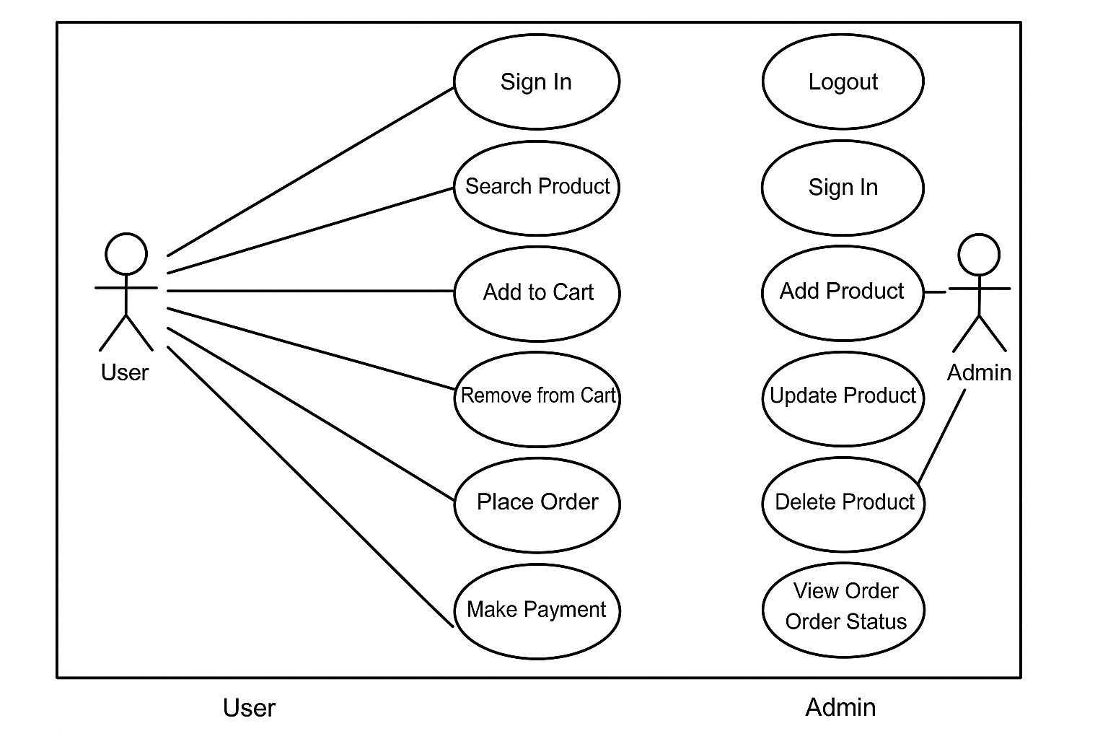
Figure 1: System Level Use Case Diagram

3.1 Use Case Description
UC-1: Sign in
Use Case ID | UC-1
Use Case Name | Sign in
Actors | User
Description | The user logs into the system using valid credential
Trigger | User inter login details and submit the form
Precondition | User must have a register account
Postcondition | The user is logged into the system and redirected to the dashboard
Normal Flow | - User go to the login page  - Users enter their username and password  - System validates the credentials  - User is logged in
Alternative Flow | Invalid credentials: system display the error message

UC-2: Search Product
Use Case ID | UC-2
Use Case Name | Search Product
Actors | User
Description | The user search for the product by entering keywords
Trigger | User initiate the search query
Precondition | System shows a list of items
Postcondition | Relevant search result is displayed
Normal Flow | - User enter the search term in the search bar  - System fetches matching products and display is
Alternative Flow | System displays no product found

US-3: Add to Cart
Use Case ID | UC-3
Use Case Name | Add to cart
Actors | User
Description | User add a product to shopping cart
Trigger | User click add to cart
Precondition | Logged in
Postcondition | Product is added to cart
Normal Flow | - User view product  - Click “add to cart”  - Confirmation message displayed
Alternative Flow | Product out of stock: show message  Not logged in: redirect to login page

UC-4: Remove from cart
Use Case ID | UC-4
Use Case Name | Remove from cart
Actors | User
Description | User remove the added product from the cart
Trigger | User chick the remove button
Precondition | Logged in
Postcondition | Selected item is removed from the cart
Normal Flow | - User views the cart  - User click the “remove” button  - System updates the cart
Alternative Flow | Cart is empty: show the message  Item already removed: show the message

UC-5: Place Order
Use Case ID | UC-5
Use Case Name | Place Order
Actors | User
Description | User placer an order for product in their cart
Trigger | User click “place order” button
Precondition | User is logged in and cart must not be empty
Postcondition | Order is recorded and confirm
Normal Flow | - User reviews the cart  - Click on “place order” button  - System processes payment and confirm the order
Alternative Flow | Payment failure: system shows message

UC-6: Cancel Order
Use Case ID | UC-6
Use Case Name | Cancel order
Actors | User
Description | User cancel the placed order
Trigger | User select “Cancel Order “
Precondition | The order must be in state which can be canceled
Postcondition | The order is marked as canceled
Normal Flow | - User views the order history  - User select an order and click “cancel order”  - System updates the order status to canceled
Alternative Flow | Order can’t be canceled: system shows the message

UC-7: Make payment:
Use Case ID | UC-1
Use Case Name | Make payment
Actors | User
Description | Make online payment through gateway
Trigger | User submit payment info
Precondition | Order created
Postcondition | Payment completed and order confirmed
Normal Flow | - Select payment method  - Enter cased details  - Confirm payment
Alternative Flow | Payment failed: show message  Time Out: show error

UC-8: Logout:
Use Case ID | UC-8
Use Case Name | Logout
Actors | User
Description | User logout from the system
Trigger | User click “logout”
Precondition | Logged in
Postcondition | User is logged out and redirect to the login page
Normal Flow | - User click the “logout” button  - System ends the session  - User is redirect to the login page
Alternative Flow | None

UC-9: Sign in
Use Case ID | UC-9
Use Case Name | Sign in
Actors | Admin
Description | The admin logs into the system using valid credentials
Trigger | The admin clicks “login” button and submit he form
Precondition | Admin must have a register account
Postcondition | Admin is logged into the system
Normal Flow | - Admin navigate to the login page  - Admin enter their user’s name and password  - The system validates the credentials  - Admin is logged in
Alternative Flow | Invalid credentials: system displays an error message

UC-10: Add Product
Use Case ID | UC-10
Use Case  Name | Add product
Actors | Admin
Description | Add a new product to the inventory
Trigger | Admin click “Add Product” button
Precondition | Logged in as admin
Postcondition | Product is saved in database
Normal Flow | Open product form  Enter details  Save the product
Alternative Flow | Missing field: show error message

UC-11: Update Product
Use Case ID | UC-11
Use Case  Name | Update Product
Actors | Admin
Description | Admin edit details of existing product
Trigger | Click “edit on product”
Precondition | Product should exit
Postcondition | Changes save in database
Normal Flow | Locate the product  Edit details  Save the change
Alternative Flow | Updating failed: Show the message

UC-12: Delete Product
Use Case ID | UC-12
Use Case Name | Delete product
Actors | Admin
Description | Remove the product from listing
Trigger | Click “delete” button
Precondition | Product must exist
Postcondition | Product no longer visible to the user or customer
Normal Flow | - Select product  - Confirm deletion  - Product removed
Alternative Flow | Product in active order: deletion is not allowed

UC-13: View Order
Use Case ID | UC-13
Use Case Name | View order
Actors | Admin
Description | View all customer’s order and status
Trigger | Click “view order” button
Precondition | Logged in
Postcondition | List of orders displayed
Normal Flow | - Admin access order panel  - Click on “see order detail” button
Alternative Flow | No order: show message

UC-14: Update Order Status
Use Case ID | UC-14
Use Case Name | Update order status
Actors | Admin
Description | Make order as shipped, delivered etc.
Trigger | Admin click on “update order status” button
Precondition | Order must exist
Postcondition | Order status update for customers
Normal Flow | - Select order  - Changes order status  - Save the update
Alternative Flow | None

UC-15: Manage Users
Use Case ID | UC-15
Use Case Name | Manage users
Actors | Admin
Description | Admin view or remove registered users or customers
Trigger | Admin click on “manage users” button
Precondition | Admin must log in
Postcondition | User list updated
Normal Flow | - View user list  - Select action (view, remove)  - Execute action
Alternative Flow | Attempt to delete admin account: show error message

4. References

- User interface style guide: Reference to standing guidelines used for designing the user interface to ensure consistency and usability https://www.w3.org/standards/
- System requirements specification: Documents detailing hardware and software requirements for deploying the system https://ieeexplore.ieee.org/Xplore/home.jsp/
- MongoDB atlas documentation: Official MongoDB atlas documentation for database setup an integration https://www.mongodb.com/docs/atlas/
- React.js documentation: Guidelines for front-end development using react.js https://react.dev/
- Node.js documentation: Official Node.js used for back-end development and API integration https://nodejs.org/docs/latest/api/

